Changing the Default Printer in Windows 11
Click on the start menu and type “Printers”. Click on the Printers & scanners option.
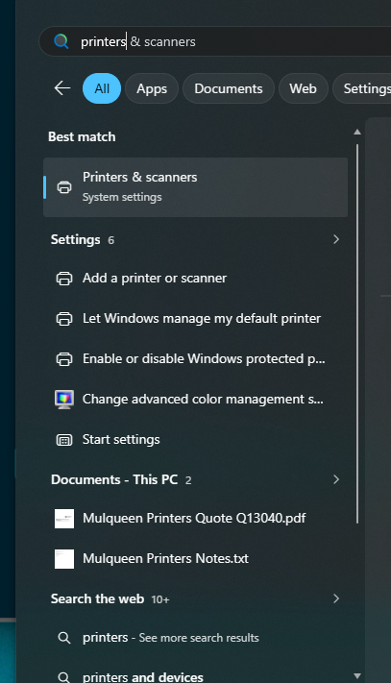

A window will appear showing you all the printers that have been setup on your computer.
Scroll down to the Printer preferences section and make sure the Let Windows manage my default printer is turned off.
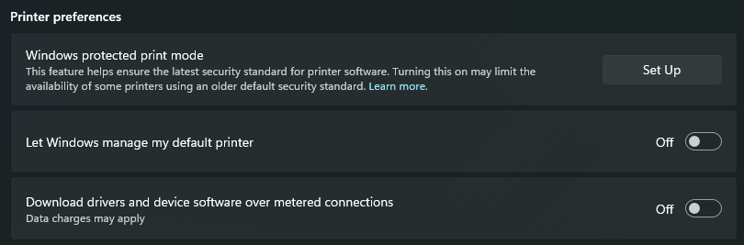
Now back up in the list of printers click on the printer you want to make your default printer and click on the Set as default button to make that your default printer.
